**Health & Safety Talk**

Toolbox Talk

[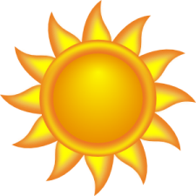](javascript:edit(15798))**Heat & Sun**

**What are the risks?**

*Heat illness, which can include:*

* Feeling sick
* Dizzy
* Weak
* Confused and disorientated
* Sun burn from direct sun exposure

*Commonly un-recognised health and safety problems which can include:*

• Loss of grip while handling tools and objects due to sweaty hands

• Errors/mistakes and cutting corners due to heat fatigue. Not following safe work practice’s and not using personal protective equipment

• Burns from contact with hot surfaces or substances.

**What should be done?**

There are many easy and practical steps which can be put in place to control excessive exposure to heat and sun, these include but are not limited to:

• Increasing air movement using fans and coolers.

• Rescheduling work so that any hot tasks are performed during the cooler part of the day.

• Wearing light clothing that still provides adequate protection.

• Reducing the time spent doing hot tasks (e.g. job rotation) or arranging for additional employees to provide assistance.

• Taking extra rest breaks in a cool area.

• Keeping cool drinking water nearby (employees are encouraged to drink 200mL of water every 15-20 mins.)

**Who is responsible?**

Everyone needs to take environmental factors into account, not just employees working outdoors.

For up to date weather and fire ban alerts visit <http://www.weatherzone.com.au/>.

|  |  |
| --- | --- |
| **Consultation** |  |

**Date of Meeting:**_____________________

**Attendees** (list attendees present)

|  |
| --- |
|  |

**Items Discussed**

|  |
| --- |
|  |

**Action Items**

|  |
| --- |
|  |

**Management Sign Off**

**Name:** _______________________________________

**Sign:** ___________________________________ **Date:** ______________________________